Alexander Mekovsky
COSC 320
Enyue Lu
3/29/2023
Lab 07 Report
Lab Report: I was able to successfully complete all parts of the lab. While I had issues at first figuring out the hash functions I was able to figure it out and finish the lab. The output to the lab is listed below:
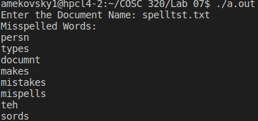

Overall I had no significant issues with the code itself, the implementation went smoothly and I even coded in checks to make sure the files actually existed. Overall the lab took me an hour and a half from start to finish, and helped me better understand the functions of hash tables and how they work.

